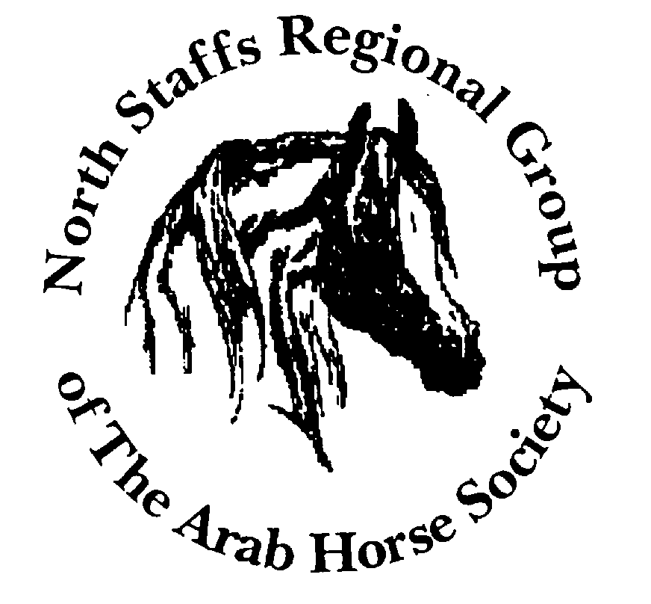

RESULTS

North Staffs AHS Summer 'C' Show.
Rodbaston College, Staffs. 1st July 2007

(M) - Denotes Member of the North Staffs Regional Group
.Courtesy of : The North Staffs Regional Group

HOYS (S Fleming)

Open Ridden Stallions.
1 & SUP CH. J Peck’s - Dervatiw Gwyddion
2, H Budge’s - Ikoni - HOYS Qualifier
3, G Stone’s - Storm Seeker. (M)
4, Miss G Rees - Valletta Hunters Moon
5, Miss Susan George - Bolaero

Open Ridden Junior Geldings
1, C Bennett’s - Al Shahrani
2, H Hyde-Andrew’s - Majestic Cavalier
3, A Embleton’s - Aybac.
4, Miss Susan George - Aktor

Open Ridden Senior Geldings.
1& Res.CH C Bennett’s - Storm Gold (M)
2, A Boyles - Maleikero
3, D Atkin’s - Silver Ffate.
4, Ms J Bond - Salazeer
5, Mrs T Sheward - Silent Storm
6, Miss L Rankin - Ras Al Jadi

Gelding HOYS Ticket ride off.
1, Storm Gold
2, Maleikero
3 Al Sharani. - Qualifier
4, Salazeer
5, Aktor
6, Silver Ffate

Open Ridden Mares.
1, S Coombs’s - Eastworth Ahmoshini - HOYS Qualifier
2, Phillips & Boyle’s - Silver Lil;
3, S Holland’s - Tukki Amira. (M)
4, Mrs B Mathews - Jameer
5, Mrs K Brown - Marzookah (M)
6, Silver Tiffany - Mrs S Rhodes & Mrs A Starkie

CHAMPION DERVATIW GWYDDION
RES.CHAMPION STORM GOLD

Novice Ridden (K Oldroyd)

Purebred Stallions.
1, P Horwell’s - AH Kuda;
2, A Hallworth’s - AJA Vespasian;
3, D Atkin’s - Final Shadow.

Novice Ridden Mares.
1 & Res SUP. D Atkin’s - Azhiqa
2, M Barlow’s - Kharalisa (M)
3, J Maher’s - PA Selenah.

Novice Ridden Geldings.
1& Res. CH. A Rose’s - ZA Karis Ibn Azal
2, K Thorogood-Le’Vell’s - OAS Plashaal
3, N Armstrong’s - NPA Hazan. (M)
4, Ms Heather Shannon - Kartier
5, Mrs Suzanne Cruise - Galoul (M)

CHAMPION AZHIQA

RES. CHAMPION ZA KARIS IBN AZAL

SUPREME RIDDEN DERVATIW GWYDDION
RESERVE SUPREME RIDDEN AZHIQA

Pure Bred In Hand (M Wragg)

Junior Yearling Filly.
1, & ResJun. Female CH -.Mr R E Pritchard’s - Inyesta
2, D Leveuf’s - Spirits Destiny
3, M Sutherland’s - Sunlights Imadge. (M)
4, Miss K Gore - Mystik Amber

Senior Yearling Filly
1 & Jun. Female - CH. M Gamlin’s - CS Christina
2 A Hallworth’s - AJA Nareyna (M)
3, Mr & Mrs D R Tyzack - Laminah
4, N Armstrong’s - NPA Habeeba. (M)
5, Mrs S Beeley - Nafisa Cameo
6, Miss P Collins - HT Nafeesa (M)

Yearling Filly
1, CS Christina - Mr M Gamlin
2, Inyesta - Mr R E Prichard

Two Year Old Filly.
1, D Tyzack’s - RL Cotton Candy
2, C Reeves’s - AV Vodkah (M)
3, P Timms’s - Exquisite Lady
4, Mrs S Holland - GE Fenike (M)
5, Veronica Mann-Wernsten - WW Isadorah

Three Year Old Filly.
1, J Adkins’s - Marleen
2, P Whitlow’s - Symphony
3, D Atkin’s - Eden Elixia. (M)

Junior Female Champion CS CHRISTINA - Mr M Gamlin
Reserve Champion INYESTA - Mr R E Prichard

Yearling Colt.
1 & Res. SUP Gamlin,Ratcliffe & Matthews’s - Don Giovanni
2, A Hallworth’s - AJA Valentino (M)
3, Fay Mathews - Cotswolds Azraff
4, H Brown’s - Kasparov.

Two Year Old Colt.
1 & Res.Jun. Male A Hallworth’s - AJA Estrravagance (M)
2, Miss C Trig & Mr J Clyne’s - Padrons Musketeer.

Three Year Old Colt
1, A Bethell’s - Audemars PA
2, W Dean’s - DE Marrenzo. (M)

Junior Male Champion DON GIOVANNI
Reserve Champion AJA ESTRRAVAGANCE

Brood Mare .
1 & Res. Sen. Mare - Miss K Gore’s - EA Amellia
2, S Beeley’s - Midnight Pearl.

Foal.
1, S Beeley’s - SJ Midnight Jamaal
2, K Gore’s - Un named foal.

Mare 4-6yrs.
1, H Cawley’s - Breathless Love Psy
2, C Reeves’s - MG Saffire (M)
3, L Bates’s - Verapamila. (M)
4, Mr A R McGregor & Miss C Lewthwaite - Hyleah El Bri
5, Mrs P Hannay - Aziza

Mare 7 & over.
1 & SUP Ch. R McCormick’s - Saszarta
2, C Reeves’s - Metelica (M)
3, J Adkins’s - Hanisha. (M)
4, Mr & Mrs E P T Whitlow - Maiad
5, Miss R Georgeson - White China Bay (M)

Stallion 4-6 yrs.
1, V Marsh’s - El Sahir
2, Mr A R McGregor & Miss C Lewthaite’s - Imahni
3, R Newnham-Peel’s - Star Ascendant. (M)

Stallion 7 & over
1 & Sen. Male CH. A Bethell’s - AJA Svengali
2 & Res CH Miss E Mercer’s - AJA Ben Nazif (M)
3, M Bint’s - Distinkt.

Senior Female Champion SASZARTA
Reserve Female Champion EA AMELLIA

Senior Male Champion AJA Svengali
Reserve Champion AJA Ben Nazif

Pure Bred Geldings( A Dixon)

Yearling Gelding
1, C Feeney’s - CF Eross. (M)

Two/Three Year Old Gelding
1 & CH. Mr & Mrs & Mr I Woodward’s - HT Orinocco (M)
2, A Meadow’s - HT White Nyle (M)
3, S Davenport’s - Psynbad.

Senior Gelding 4 & over.
1 & Res.CH S Warne’s - Shadli
2, P Collins’s - HT Navarro (M)
3, A Coupe’s - Madryn Calypso. (M)
4, Mr & Mrs A B Hill - Ffrivolity (M

Gelding Champion HT ORINOCCO
Reserve Champion SHADLI

SUPREME IN-HAND CHAMPION SASZARTA

RESERVE SUPREME CHAMPION DON GIOVANNI

MAG Qualifier Young Riders (K Oldroyd)
1, Kiri Thorogood-Le’Vell - OAS Plashaal
2, Natalie Johnson - Spyros (M)
3, Jodie Maher. - PA Selenah (M)

Restricted Open Ridden (K Oldroyd)

1, T Sheward’s - Fallen Shadow (M)
2, A Hill’s - Ffrivolity (M)
3, L Breeze’s - Zinjadi. (M)
4, Mrs M Bint - Distinkt (M)

Junior Rider (L Lidbury)
1, Bethany Bates - Dahabb (M)
2, Miss Natalie Johnson.Cruise - Spyros (M)

Ridden Anglo & Partbred (L Lidbury)

Novice Ridden
1 & ResCH Mr D Whittard’s - Comanche Deuce (M)
2, Mr & Mrs I Cole’s - Vlacq Redwood Reflection. (M)

Open Ridden Anglo & Partbred 153cms & under
1, C Phipps-Hewlett’s Hurstpark - Jubilees Tabatha
2, Miss L Johnson’s - Trellech Countryman. (M)

Open Ridden Anglo & Partbred over 153cms.
1 & CH. L Stainburn’s - Fairlyn First Edition (M)
2, Mr D Whittard’s - Commanche Deuce (M)
3, Miss K A Thachham - Fiddler on the Hoof (M)
4, Mrs M Bint - Palacazarr - (M)
5, Mr & Mrs I Cole’s - Vlacq Redwood Reflection. (M)

AA /PB NOVICE/OPEN RIDDEN CHAMPION FAIRLYN FIRST EDITION (M)
RESERVE CHAMPION COMANCHE DEUCE (M)

Amatuer/ Home Produced (A Dixon)

Purebred Ridden.
1, Kiri Thorogood-Le’Vell - OAS Plashaal
2, B Bates’s - Dahabb (M)
3, M Barlow’s - Kharalisa (M)
4, Mrs S Cruise - Galoul (M)
5, Mrs D Roach - Island Merek (M)
6, Mrs A Coupe - Madryn Calypso (M)

Anglo/Partbred Ridden.
1 & Res. AM CH. Miss L Johnson - Trellech Countryman (M)
2, L Stainburn’s - Fairlyn First Edition (M)
3 Miss Ceri Phipps-Hewlettt - Hurstpark Jubilees - Tabatha
4, Jackie Shepard - Sameon Summer Thyme

Purebred 1/2/3/ yrs
1, Mrs C A Feeney - CF Eross (M)
2, Miss P Collins - HT Nafeesa (M)

Purebred In Hand 4 & over.
1, S Warne’s - Shadli
2, P Shenton’s - El G Sanan (M)
3, Mrs A Coupe - Madryn Calypso. (M)
4, Mrs L Bares & Miss B L Bates - Dahabb (M)
5, Mrs S Cruise - Spyros (M)

Anglo/Partbred 1/2/3-y-o
1, H Ludlow’s - Waltsir Way Dreaming (M)
2, R Knott’s - Vlacq Emerald Icon (M)
3, J Gething’s --Lady Indiana (M)
4, Wendy Dawes - Rex of Torthorwald (M)

Anglo/Partbred 4 & over.
1 & AM. Ch. L Heery’s - Gordons Ginny
2, L Stainburn’s - Fairlyn First Edition (M)
3, Miss L Johnson - Trellech Countryman (M)
4, Mr & Mrs I Cole’s - Vlacq Redwood Reflection. (M)
5, Miss K A Thachham - Fiddler on the Hoof (M)
6, Mark Kirkland - Sameon Summer Thyme

AMATEUR CHAMPION GORDON’S GINNY
RESERVE CHAMPION TRELLECH COUNTRYMAN (M)

Young Handler. (L Lidbury)
1, Natalie Johnson Cruise (M)
2, Jordan Kirkland
3, H Ludlow. (M)

Anglo/Part bred In Hand (L Lidbury)

AA/PB Yearling
1, Miss H Ludlow - Waltsir Way Dreaming. (M)

AA/PB 2/3-y-o Filly/Gelding.
1, L Tait’s - Downies Mystic Melody
2, J Gething’s - Lady Indiana (M)
3, Mr R Knott - Vlacq Emerald Icon. (M)

AA/PB Mare
1, L Heery’s - Gordons Ginny
2, A Meinhardt’s - Hightime Rock N Roll Roxy (M)
3, T Carswell’s - Paddock Paragon.
4, Miss H Ludlow - Ridgeway Perfect Waltz (M)

AA/PB Foal.
1, A Meinhardt’s - Hightime Classical Solo (M)
2, T Carswell’s - Paddlow Supernova.

AA/PB Geld 4 & over.
1 & Res.CH - Miss L Stainburn - Fairlyn First Edition (M)
2, Miss L Johnson - Trellech Countryman. (M)

AA/PB Stallion.
1 & CH N Helliwell’s - A Chance of Fame (M)
2, Arabian Training Centre’s - JCS Aramoon.

AA/PB IN-HAND CHAMPION N Helliwell’s - A Chance of Fame (M)
RESERVE CHAMPION Miss L Stainburn - Fairlyn First Edition (M)

Open Coloured(Any Age)
1, N Helliwell’s - A Chance of Fame (M)
2, Arabian Training Centre’s - JCS Aramoon.
3, D Whittard’s - Comanche Deuce. (M)

DRESSAGE
PRELIMINARY 12

1, Mrs R Newnham-Peel (Miss Evie Peel) - Taragun (M)
2, Miss M A Barlow - Kharalisa (M)
3, Mr & Mrs N P Armstrong - NPA Hazan (M)
4, Mr & Mrs A B Hill - Ffrivolity (M)
4, Mrs S Cruise - Galoul (M)
5, Mr & Mrs I Cole - Vlacq Redwood Reflection (M)

NOVICE 25

1, Mrs R Newnham-Peel (Miss Evie Peel) - Taragun (M)
2, Mr D Whittard’s - Comanche Deuce (M)

OVERALL DRESSAGE (Highest % Pure - Highest % AA/PB)

Pure Bred
Mrs R Newnham-Peel (Miss Evie Peel) - Taragun (M)

Anglo/Part Bred
Mr D Whittard’s - Comanche Deuce (M)

VERSATILE - BIATHLON
=1, Mr D Whittard’s - Comanche Deuce (M)
=1, Miss L Johnson - Trellech Countryman. (M)
2, Miss M A Barlow - Kharalisa (M)
=3, Mr & Mrs A B Hill - Ffrivolity (M)
=3, Mr & Mrs I Cole - Vlacq Redwood Reflection (M)
4, Miss K A Thachham - Fiddler on the Hoof (M)
5, Mrs Suzanne Cruise - Galoul (M)
6, Natalie Johnson.Cruise - Spyros (M)

VERSATILE - TRIATHON
1, Mr D Whittard’s - Comanche Deuce (M)
2, Mr & Mrs A B Hill - Ffrivolity (M)
3, Mr & Mrs I Cole - Vlacq Redwood Reflection (M)

