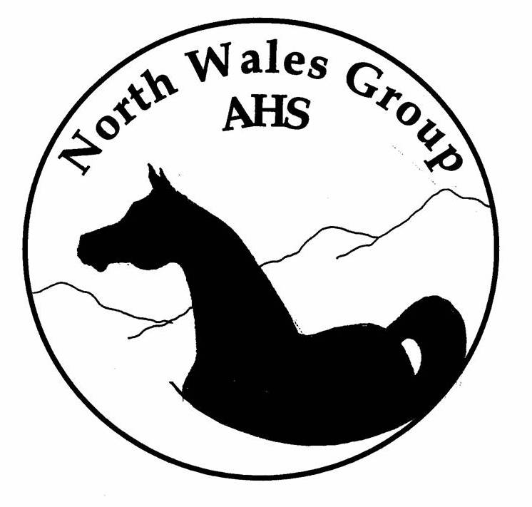
Saturday 29th November 2009
‘Natter & Noggin’
Tack Sale & Social
Clwyd Special Riding Centre
Llanfynydd – 8 pm

ALL
WELCOME!

Let’s face it, we all have horsey things we don’t use – but someone else may be looking for that very ‘thingamy’… so help raise funds for the group and top up your own Christmas kitty

- Clear out your tack rooms & wardrobes
- Submit your list & label your booty
- Come along – sell, eat, drink & be merry
- Bag some bargains
- ‘Top Table’ Ballot & refreshments

www.northwalesarab.co.uk
laura@northwalesarab.co.uk
01352 770238 for info

