National pony society
Area 27 north Wales
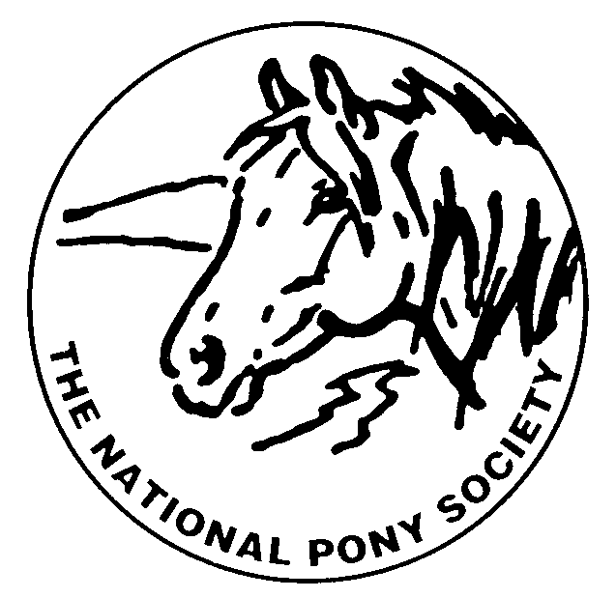

List of events 2008/2009

Thursday 4th Dec Christmas Dinner
At the Faenol fawr bodelwydden
Ridden Show to be confirmed
Teach in to be confirmed
Spring youngstock show 25th April
At Brynrefail, Bangor
Summer show 28th June
At Muleberry

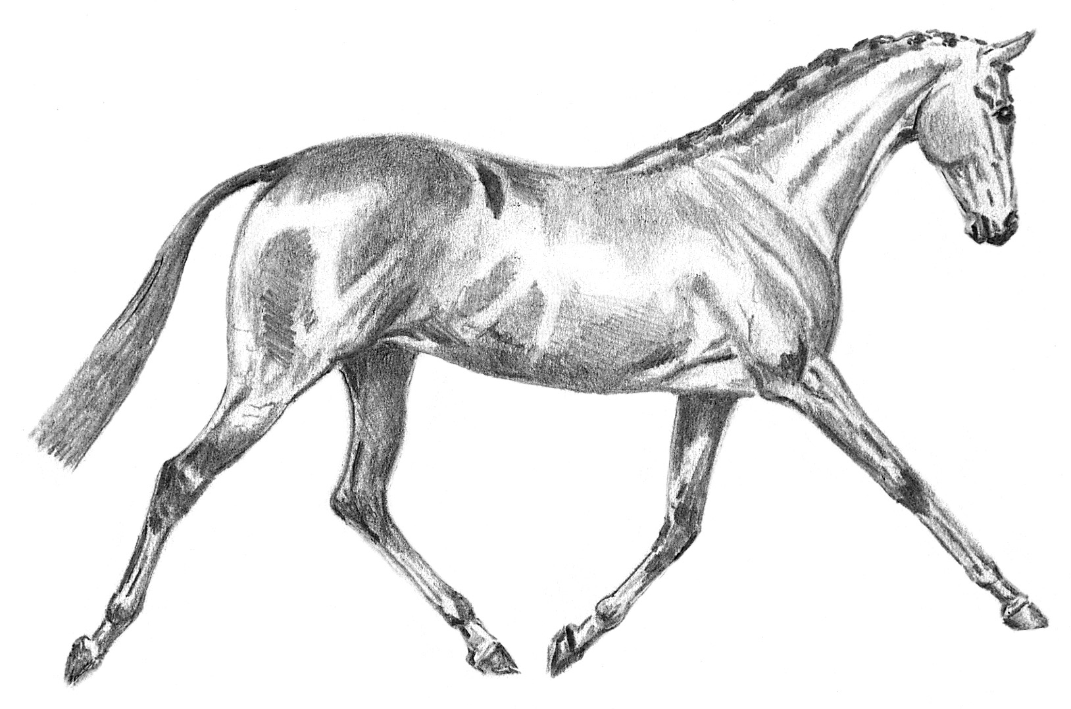
National pony society
Area 27 north Wales

Foal show sat 25th Oct 2008
Held at the Equine college Northop Flintshire

(members rosettes awarded in every class, blue armband essential)

Open to all showing enthusiasts’ members and non-members all are welcome.
NPS AREA 27 WOULD LIKE TO THANK ALL THE GENEROUS PEOPLE, ORGANISATIONS & STUDS WHO SPONSORED VARIOUS SECTIONS AT THIS SHOW!

North wales arab group of the AHS
Royalview Stud
Telynau Stud
Rohey Stud
Rhydeilian Stud
Parciau Stud
Doulton Stud
Wellbank Stud
Rhydyfelin Stud
Robenn Stud
Pentref Stud
Kalusta Stud
Brohelegan Stud
Deliva Stud
Aberconwy Equestrian
Ynys Mon Shetlands
Nps area 27 committee

Chairman: Mr D. W. Jones
Secretary: Miss Karen Stanley
Treasurer: Mrs J. Williams

Committee members
Mr I. Williams
Mr K. Bennett
Miss P. Edwards

ENTRY SECRETARY,
Mrs. L. Edwards,
15 Henrietta Street, Shotton, Flintshire. CH5

Website updating Mrs L. Carruthers
Schedule compiling: Miss A. Roberts

RING 1 CONTINUED.
Pure, Anglo & Part Bred Arab
Judge: Mrs S Wade (Kelsborrow)

Class 30: pure bred arab foal
Class 31: Part bred or Anglo foal not to exceed
148 cms at maturity.
Class 32: Part bred or Anglo foal exceeding 148cms
at maturity.

Championship 11
Open to first and second prize winners from classes 30 – 32.

------------------------------------------------------------------------------------------------------------------------------

SUPREMES TO BE JUDGED BY ALL JUDGES

M & M SUPREME FOAL. OPEN TO CHAMPIONS FROM CHAMPIONSHIPS:
3, 5, 7, 8, 9 & 10

Non M & M SUPREME FOAL. OPEN TO CHAMPIONS FROM CHAMPIONSHIPS:
1, 2, 4, 6 & 11

OVERALL SUPREME FOAL. OPEN TO CHAMPIONS to be judged by a celebrity!
F

Ring 1 starting at 10am prompt.
Judge: Mrs J Stuart (Starlyte)
Riding pony foals

Class 1: Foal to make a lead rein/first ridden
Class 2: foal to exceed 122cms not to exceed 128cms
Class 3: foal to exceed 128cms not to exceed 138cms
Class 4: foal to exceed 138cms not to exceed 148cms

Championship 1
Open to first and second prize winners from classes 1 – 4.

Hunter pony foals

Class 5: foal not to exceed 122cms
Class 6: foal to exceed 122cms not to exceed 133cms
Class 7: foal to exceed 133cms not to exceed 143cms
Class 8: foal to exceed 143cms not to exceed 153cms

Championship 2
Open to first and second prize winners from classes 5 – 8

MOUNTAIN AND MOORLANDS (to include welsh sections)

Class 9: Dartmoor, exmoor or shetland foal
Class 10: welsh A /B foal
Class 11: Dales, fell or highland foal
Class 12: New forest or connemara foal
Class 13: welsh c/d foal

Championship 3
Open to first and second prize winners from classes11 – 13.

Ring 1 continued

JUDGE: Mr A Fletcher (Dhanak)
WELSH PART BREDS
(Must have 12.5%welsh blood)

Class 14: welsh part bred Colt foal
Class 15: welsh part bred Filly foal

Championship 4
Open to first and second prize winners from classes 14 & 15.

JUDGE: Mrs S Wade (Kelsborrow)
SHETLANDS

If sufficient entries are received miniatures may have their own classes.

Class 16: Shetland colt foal
Class 17: Shetland filly foal

Championship 5
Open to first and second prize winners from classes 16 & 17.

Judge Mrs S Wade (Kelsborrow)

Open foal classes

Class 26: foal likely to make a hack/riding
Class 27: hunter foal
Class 28: sports horse/pony foal
Class 29: coloured foal

Championship 6
Open to first and second prize winners from classes 26 – 29
Ring 2 starting at 10am prompt

Judge: Mr S Franklin (Sarum)
Welsh section A

Class 18: welsh section a colt foal
Class 19: welsh section a filly foal

Championship 7
Open to first and second prize winners from classes 18 – 19

Welsh section b

Class 20: welsh section b colt foal
Class 21: welsh section b filly foal

Championship 8
Open to first and second prize winners from classes 20 - 21

Judge: Mr A Fletcher (Dhanak)
Welsh section c

Class 22: welsh section c colt foal
Class 23: welsh section c filly foal

Championship 9
Open to first and second prize winners from classes 22 – 23

Welsh section d

Class 24 welsh section d colt foal
Class 25 welsh section d filly foal

Championship 10
Open to 1st & 2nd prize winners from classes 24 &25

